MANUSCRIPT TITLE, 16 POINTS BOLD

Author Names and Affiliation

The abstract should be single-spaced with no more than 250 words.
Key words: Up to five keywords, in italic.

THIS IS A SAMPLE OF A GENERAL SECTION HEADING
The manuscript goes here. Subsection headings are in italic.
Equations. Equations are centered with the equation number to the right.
$$y=f(x)$$ | (1)
In the text, equations should be referenced by name as Eq. (1) or Equation (1).
Figures and Tables. Illustrations are referenced by name and without formatting embellishments, such as Figure 1, Table 1, etc. Each illustration should have a caption as shown below.
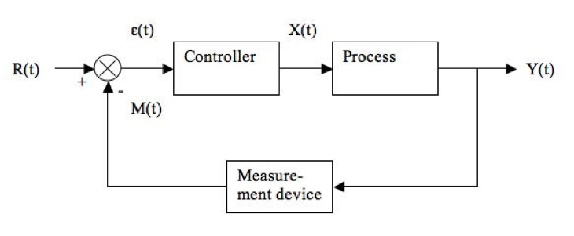
Figure 1. Control block diagram

Test 1 (SOC_f=50%) | Test 2 (SOC_f=30%)
Data from test 1 | Data from test 2
Table 1. Example of a Table

References and Citations. References should be consistent in form. Citations should be sufficient to allow the reader to precisely find the information being cited, as shown.

ABBREVIATIONS
List of abbreviations can be added here (see example below) if needed.
SOC: | State of Charge

REFERENCES
[1] Names of authors, “Title of publication,” Journal name, Vol. XX, No. X, (year), pp. XX–XX.

